PRESS RELEASE
INTERNATIONAL COASTAL CLEAN UP (ICC) DAY- 17 SEP 16
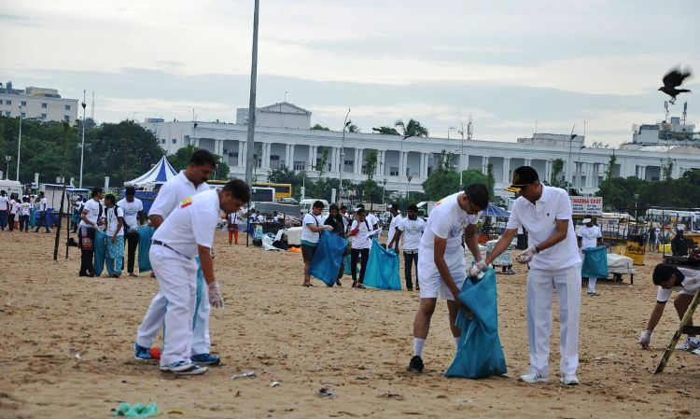
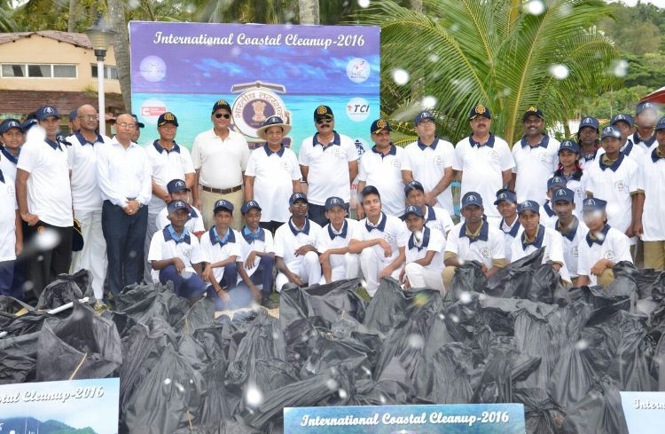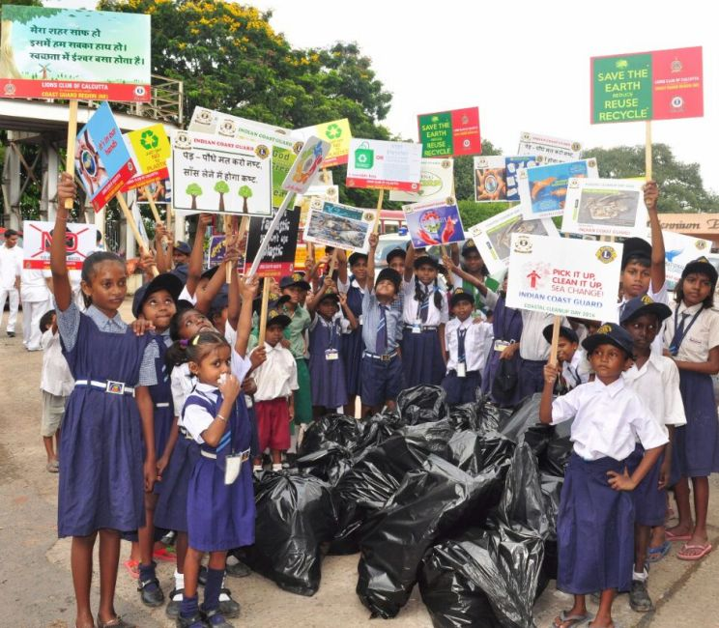
The Indian Coast Guard alongwith school/ college children and State Administration organised ‘Coastal Cleanup’ in all the 09 Coastal States and 04 U/Ts along the Indian Coast on 17 Sep 16, as part of International Coastal Clean Up (ICC) Day.
The ICC day is conducted in the 3rd week of Sep every year in various parts of the world under the aegis of United Nations Environment Programme (UNEP) and South Asian Cooperative for Environment Programme (SACEP) in the South Asian Region. In India, the Indian Coast Guard (ICG) has been coordinating the ‘Coastal Cleanup Day’ programme on behalf of SACEP since 2006 through its Regional/ District/ Station Headquarters located in coastal states/ UTs along the Indian Coast. An overwhelming participation has been observed from coastal states administration, NGOs and school/ college children. The objective of organizing the ICC is to generate greater awareness for the conservation and protection of the Marine Environment, especially amongst the youth and school children.
This year ‘ICC-2016’ is also being seen as a drive, that the Govt. of India has launched through its “Swachch Bharat Abhiyan”. It is the ICG’s endeavor to extend this noble drive to the outer limits of Maritime Zones of India through its “Swachch Sagar Abhiyan”.

