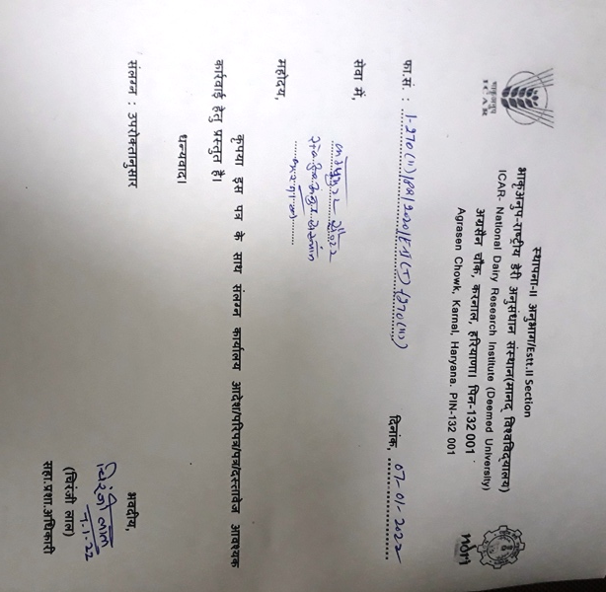

EASTABLISHMENT –II (T) SECTION
ICAR-NATIONAL DAIRY RESEARCH INSTITUTE
KARNAL – 132 001 (HR.)

NOTICE FOR CANCELLATION OF WALK IN INTERVIEWS TO BE CONDUCTED W.E.F. 10-01-2022 TO 15-01-2022 FOR THE SELECTION OF VARIOUS CONTRACTUAL POSITIONS.

F.No.1-270(ii)/PR/2020/E-II(T)-(270) Dated : 07-01-2022.

This is brought to the kind notice of all participating candidates that due to all of sudden increase of COVID-19 positive cases in the Country, the Walk-In-Interviews scheduled to be conducted at this Institute w.e.f. 10-01-2022 to 15-01-2022 for selection on the various contractual positions (Listed at Sr. No. 06 to 11 of the Walk In Interview Advertisement uploaded on ICAR-NDRI web site on dated 22-12-2021) have been cancelled till further orders. Therefore, the interested candidates are requested not to visit at ICAR-NDRI Karnal for attending the Walk in Interviews w.e.f. 10-01-2022 to 15-01-2022.
Inconvenience caused is highly regretted pl.

(This issues with the approval of Director, ICAR-NDRI, Karnal.)

Sd- Asstt. Admn. Officer

