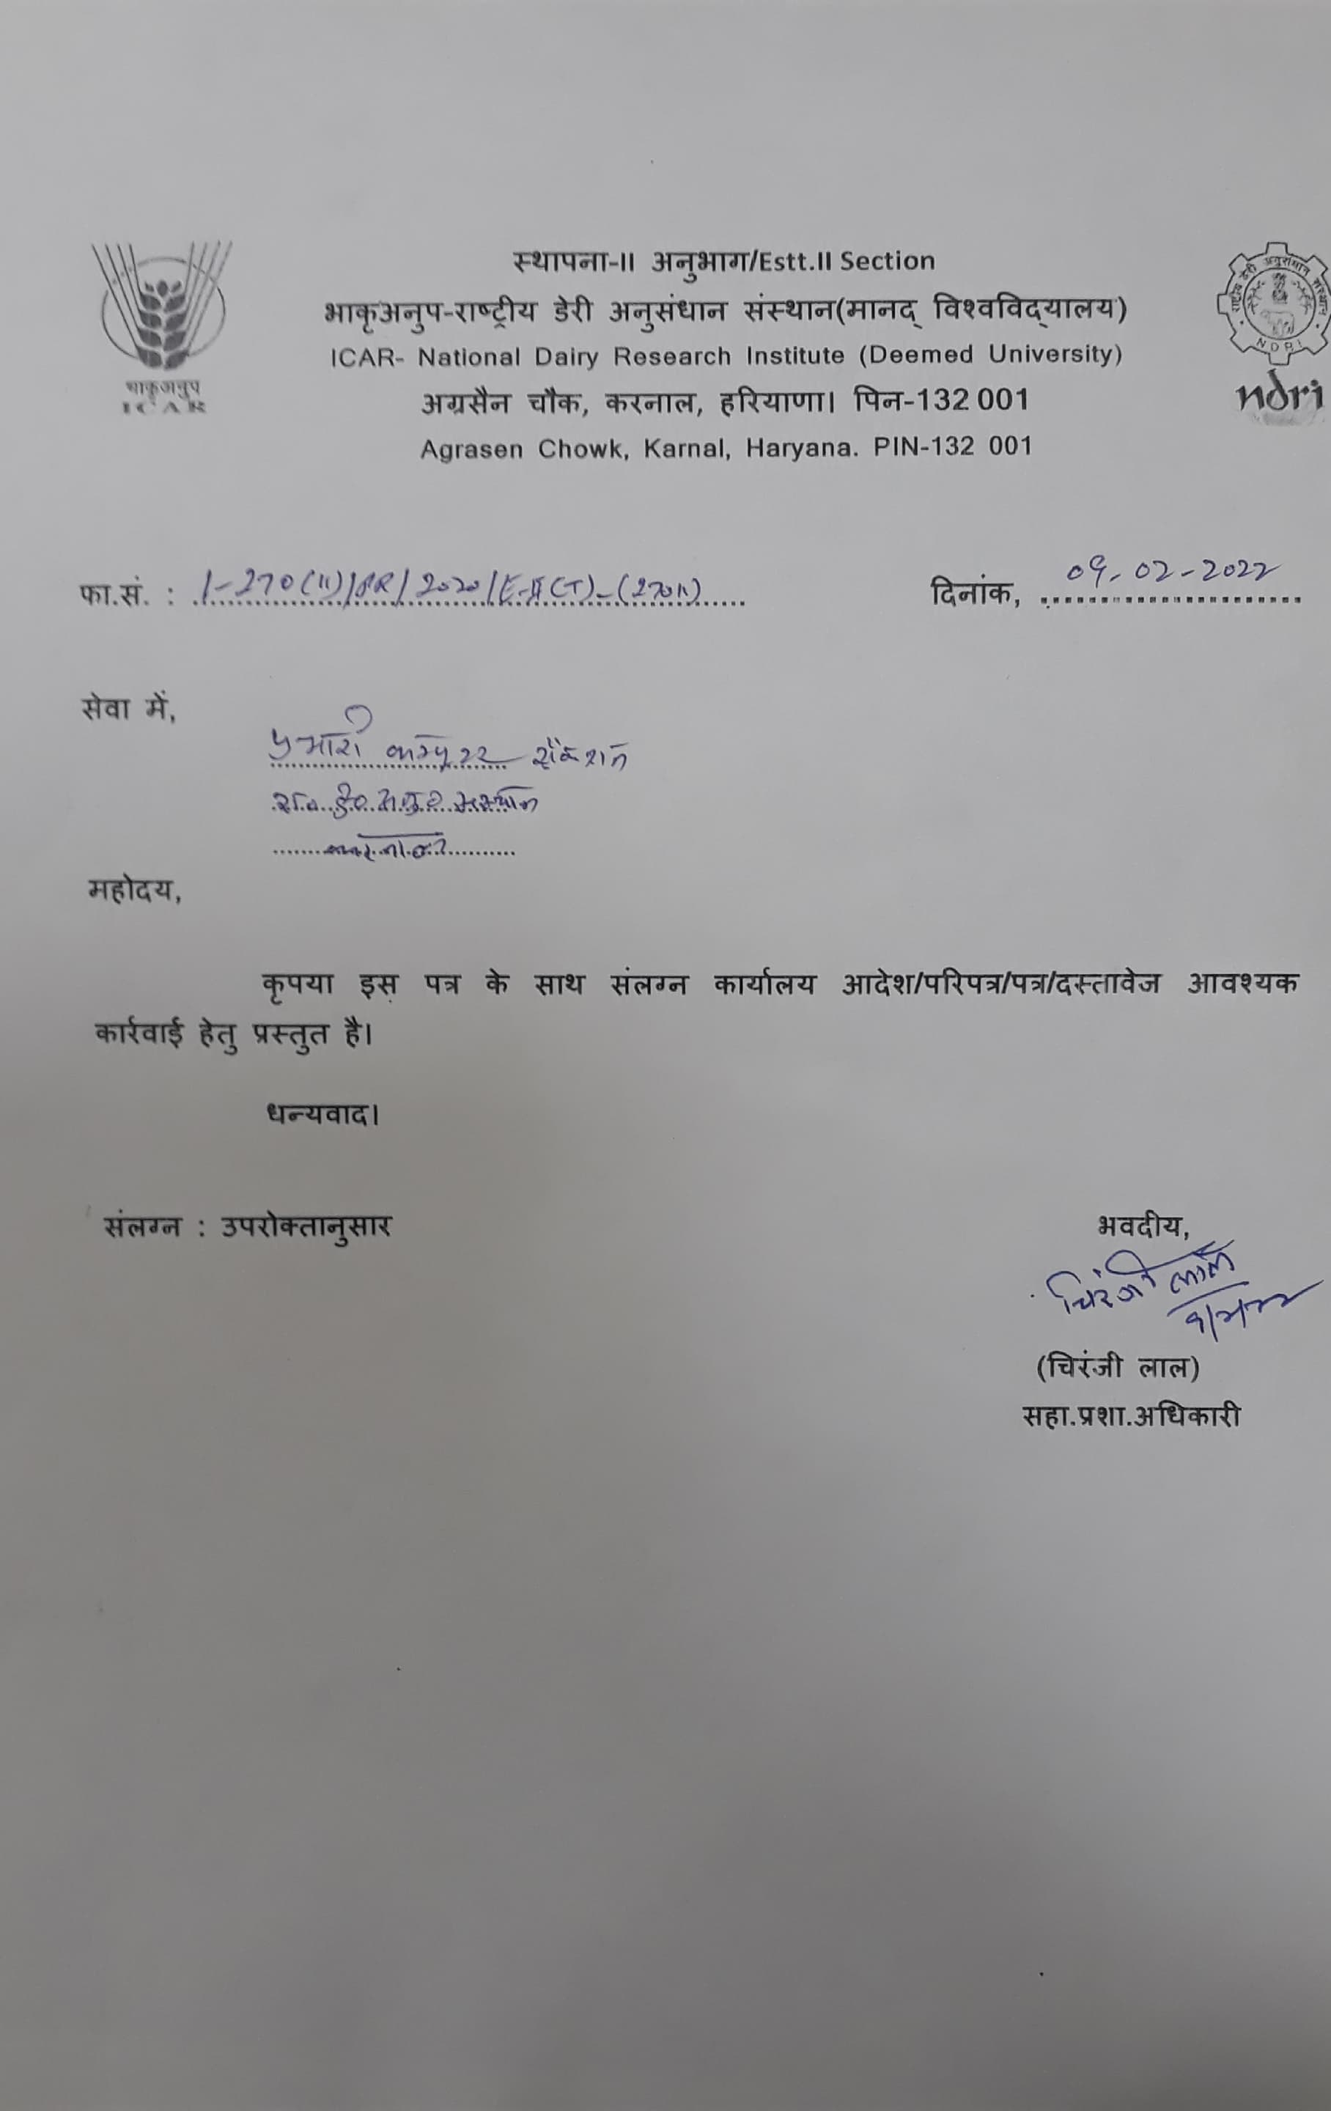

|  |  |
| --- | --- |
| |  | | --- | |  | |

**ICAR-NATIONAL DAIRY RESEARCH INSTITUTE**

**KARNAL-132001 (HR.)**

**Notice for Walk-In Interviews**

F. No. 1-270(ii)/PR/2020/EII(T)-(270ii)- Date: 9th Feb, 2022.

The Walk-in-Interviews for the selection on the contractual positions of Senior Research Fellow, Junior Research Fellow, Young Professional-I & II, Office Assistant etc. in below mentioned Projects/Schemes/Institute’s funds will be conducted at this Institute on the date, time and venue and other details shown against each position. The below mentioned positions are purely temporary in nature which are co-terminus with the Project/Scheme. The eligible candidates are invited to appear before the Selection Committee for Walk-in-Interview at ICAR- NDRI, Karnal as per below schedule.

|  |  |  |  |  |
| --- | --- | --- | --- | --- |
| **Name of the Project/Scheme** | **No. & Name of the Position and Emoluments** | **Duration** | **Place and Date of Interview** | **Qualifications** |
| 1. ICAR-NDRI Institute’s funds (Grants operational head) under Sh. Dheeraj Sharma, Deputy Director (Official Language), ICAR-NDRI Karnal. | Young Professional-I, 01(One)  Rs. 25,000/- Fixed. | One Year | Office of the Official Language, DES&M Division ICAR-NDRI Karnal  on  19-2-2022  at 10.00 A.M. | **Essential qualification: (A)**   1. Post Graduate in Hindi/English/Sanskrit with English/Hindi/English as a subject at the Graduation level.   Or   1. Graduation in Hindi/English/Sanskrit with English /Hindi/English as another subject at the Graduation level   Or   1. Post Graduate/Graduate in any subject with Hindi medium and English/Hindi as a subject at the Graduation level.   **(B):** Candidate must have Typing speed in Hindi 30 words per minute and typing Speed in English 40 words per minute.  **Desirable qualification**: Diploma in Translation or experience of translation from any Institution. |
| 2. UNDP Research Project ”Preparation of inventory of GHG emission from Indian Livestock for 2019 (Project No: 1013147) under Dr. Goutam Mondal, PS & PI, Animal Nutrition Division ICAR-NDRI, Karnal. | Senior Research Fellow 01 (one)  Rs. 31,000/- per month plus HRA as applicable for 1st & 2nd Year, Rs. 35,000/- per month plus HRA as applicable for 3rd year. | Upto 31-12-2022 | AN Division, ICAR-NDRI, Karnal on  21-02-2022 at 10.00 A.M. | **Essential Qualification:**  Master degree in Biochemistry/ Biotechnology/ Microbiology with 4 years/5 years of bachelor’s degree. Candidate having post graduate degree in basic science in (Biochemistry or Biotechnology or Microbiology) with 3 years of bachelor’s degree and 2 years master’s degree should have NET qualification and 2 years of research experience.  Desirable qualification: Work Experience in Rumen Biotechnology/Microbiology and capable of animal handling, Blood/Rumen liquor collection and publication in relevant filed. |
| 3. UNDP Research Project “Preparation of inventory of GHG emission from Indian Livestock for 2019 (Project No: 1013147) under Dr. Goutam Mondal, PS & PI, Animal Nutrition Division ICAR-NDRI, Karnal. | Office Assistant 01 (one)  Rs. 15,000/- per month Fixed | Upto 31-12-2022 | AN Division, ICAR-NDRI, Karnal on  22-02-2022 at 10.00 A.M. | **Essential qualification:-**  Graduation in any discipline with an aggregate of minimum 55% or above marks.  **Desirable qualification** :- Knowledge in MS Excel, MS word and work experience in GHG inventory preparation. |
| 4. ICAR-NDRI Institute’s funds (Grants operational head) under Dr. Naresh Selokar, Scientist, ABTC, ICAR-NDRI, Karnal. | Young Professional-I 01 (One)  Rs. 25,000/- per month Fixed. | Upto 31-03-2022 | ABTC  ICAR-NDRI, Karnal  On  23-02-2022  at  10.00 A.M. | **Essential Qualification:** Bachelor’s degree in Life Sciences/Animal Sciences/Veterinary Sciences/Agriculture Sciences.    **Desirable Qualification**: The candidate may have experience working in a scientific laboratory/Institution. |
| 5. ICAR-NDRI Institute’s funds under Dr. Vikas Vohra, PS and In charge record room, AG & B Division, ICAR-NDRI Karnal. | Young Professional-I 01 (One)  Rs. 25,000/- per month fixed | Upto 31-03-2022 (Likely to continue subject to availability of funds) | AG& B Division, ICAR-NDRI Karnal  On  24-02-2022 at 10.00 A.M. | **Essential Qualification:-** Graduation in any field with minimum aggregate of 55% Marks.  **Desirable qualification**: Candidate having one year diploma in Computer from Government recognized Institution with Minimum 02 years experience in handling Animal Data/Lab Work will be given preference. |
| 6. ICAR XII Plan Scheme *“Semen Sexing in cattle-B”* under Dr. Sudarshan Kumar, Sr. Scientist & PI, ABTC, ICAR-NDRI, Karnal | Senior Research Fellow 01 (one)  Rs. 31,000/- per month plus HRA as applicable for 1st & 2nd Year, Rs. 35,000/- per month plus HRA as applicable for 3rd year. | 31-03-2022  (Likely to continue subject to availability of funds) | ABTC  ICAR-NDRI, Karnal  On  25-02-2022  at  10.00 A.M. | **Essential Qualification:-** Master’s degree in any one of Discipline/Subject: Biotechnology/Biochemistry/Physiology/Life Sciences from a recognized university with 4 years/5years bachelor’s degree. Candidate having post graduate degree in basic science with 3 years bachelor’s degree and 2 years of master degree in above discipline/subject should have NET qualification and 2 years of research experience.  **Desirable qualification**: The candidate should have experience in sperm handling cell culture techniques, proteomics with a strong interest in Bioinformatics/experience in Molecular biology techniques like gene cloning, recombinant protein expression, purification and characterization & custom development of antibodies. |
| 7. ICAR XII Plan Scheme *“Semen Sexing in cattle-B”* under Dr. Sudarshan Kumar, Sr. Scientist & PI, ABTC, ICAR-NDRI, Karnal | Young Professional-I, 01(One)  Rs. 25,000/- Fixed. | 31-03-2022  (Likely to continue subject to availability of funds) | ABTC  ICAR-NDRI, Karnal  On  25-02-2022  at  2.30 P.M. | **Essential Qualification:-** Bachelor’s degree in Commerce(B.Com/BBA/BBS) with an aggregate of minimum 60% marks from a recognized University/Collage( with minimum 01 year of experience in relevant field).  **Desirable Qualification**:- Minimum two years of experience in working on Computer and MS Office. |
| 8. ICAR-NDRI Institute’s funds (Grants) EFC of 2021-26 under Sh. Sandeep Deswal, ACTO, Sports Cell ICAR-NDRI, Karnal. | Young Professional-I 01(One)  Rs. 25,000/- Fixed. | One Year | Sports Complex ICAR-NDRI Karnal on  26-02-2022  At  10.00 A.M. | **Essential Qualification:-** Post Graduate Degree in Physical Education/Sport Science.  **Desirable Qualification**:-  1.Candidate participated at National/All India Inter University in Sports Meets/Competitions.  2. Candidate having NCC Army Wing will be preferred.  3. Candidate having NCC “C” Certificate will be preferred.  4. Experience of teaching physical education at School/Collage level. |
| 9. ICAR Research Project *“Capacity Building of Resource Poor Farmers in Paddy-Wheat cum Dairy Production Systems through Farmer FIRST Programme under Irrigated Agro-Eco. Region of Haryana” ”* under Dr. Gopal Sankhala, PS & PI, Dairy Extension Division, NDRI, Karnal. | Senior Research Fellow  01(One)  Rs. 31,000/- per month plus HRA as applicable. | Upto  31-03-2022 | Dairy Extension Division, NDRI, Karnal  On  28-2-2022  At 10.00 A.M. | **Essential Qualification:-** Master Degree in Agricultural Extension/Veterinary Extension/ Dairy Extension/Agricultural Economic/Dairy Economic/Veterinary Economic from a recognized university with 4years or 5 years of Bachelor Degree. Candidates having Post-Graduate degree in above discipline in Basic Sciences with 3 years Bachelor degree and 2 years Master degree should have NET qualification and 2 years of research experience.  **Desirable**:-   1. Good knowledge/proficiency in computer application particularly use of MS office and SPSS/SAS. 2. Field experience in Agricultural & Social Sciences.   Proficiency in data collection & analysis. |
| 10. MoFPI Research Project “Production of dairy powder from by-products (ghee residue and butter milk): Characterization and application in heat desiccated products/convenience formulation” under Dr. G.S. Meena, Scientist & PI, DT Division ICAR-NDRI, Karnal. | Senior Research Fellow  01 (One)  Rs. 31,000/- per month plus HRA as applicable. | Up to 10-03-2023 | DT Division ICAR-NDRI, Karnal  On  02-03-2022 at 10.00 A.M. | **Essential Qualification:** Post graduate degree in Dairy Technology/Dairy Engineering /Dairy Chemistry/Food Technology/Food Engineering/Food Chemistry/Dairy Microbiology/Food Microbiology with NET qualification and 02 years of research experience. |
| 11. ICAR-NDRI Institute’s funds (Grants) EFC of 2021-26 under Dr. S. De, PS & Incharge, ABTC, ICAR-NDRI, Karnal. | Young Professional-I 01(One)  Rs. 25,000/- Fixed. | One Year | ABTC of ICAR-NDRI Karnal  On  03-03-2022 at 10.00 A.M. | **Essential Qualification**: Bachelor’s degree in Veterinary Sciences /Biotechnology Or Post graduation in Veterinary Sciences /Biotechnology.  **Desirable Qualification**: The candidate may have experience in molecular biology techniques, cell culture and bioinformatics. |
| 12. ICAR-NDRI Institute’s funds (Grants) EFC of 2021-26 under Dr. Naresh Kumar, PS, DM Division of ICAR-NDRI, Karnal. | Young Professional-II, 01(One)  Rs. 35,000/- Fixed. | One Year | DM Division  ICAR-NDRI Karnal  on  04-03-2022 at 10.00 A.M. | **Essential Qualifications:** Post Graduate Degree in Dairy Microbiology / Food Microbiology / Food Safety & Quality Assurance / Agricultural Microbiology / General Microbiology / Biotechnology.  **Desirable Qualification** : One year experience in the field of Food safety ,Quality assurance , Biosensor development and testing of milk and other products for Microbiological parameters. Candidates having Good knowledge in computer application particularly in use of MS office, excel will be given preference. |
| 13. SERB Research Project “Evaluation of Bio-functional attributes of extracellular components derived from probiotic lactobacilli as “postbiotics” under Dr. Rajeev Kapila, PS & PI, ABC Division of ICAR-NDRI Karnal. | Junior Research Fellow  01(One)  Rs. 31,000/-per month plus HRA @8%. | Upto November, 2023. | ABC Division ICAR-NDRI Karnal on  05-03-2022 at 10.00 AM | **Essential Qualification:** M. Sc./M.Sc. (Hons)/M.V.Sc./M.Tech Degree in Biochemistry/Animal Biochemistry/Microbiology/Dairy Microbiology/Biotechnology/Animal Biotechnology/Molecular Biology with NET qualification.  **Desirable Qualification**: Experience in the area of probiotics or probiotic foods along with hands on knowledge of routine techniques in Biochemistry/Molecular Biology/Microbiology/Tissue culture/Small animal model handling etc. |
| 14. ICAR-NDRI Institute’s funds (Grants) under Dr. Pawan Singh, PS & Incharge, ABRC, ICAR-NDRI, Karnal. | Young Professional-I 01(One)  Rs. 25,000/- Fixed. | One Year | ABRC Section of ICAR-NDRI Karnal on  07-03-2022 at 10.00 A.M. | **Essential Qualification**: M.Sc. in microbiology/ medical laboratory technology/ medical microbiology/industrial microbiology.  **Desirable Qualification**: Knowledge of microbiological/ staining techniques, microscopy and hematological parameters. Experience of handling different analytical instruments. |
| 15. ICAR-NDRI Institute’s funds (Grants) under Dr. A.K. Dang, PS & Head AP Division, ICAR-NDRI, Karnal. | Young Professional-I 01(One)  Rs. 25,000/- Fixed. | One Year | Animal Physiology Division ICAR-NDRI Karnal  on  08-03-2022 at 10.00 A.M. | **Essential Qualification**:- Post graduate degree in any stream having good knowledge in Computer applications and typing skills in both Hindi and English. |

**Important Note:-**

1. **For the selection for the positions of Young Professional-I &II, at least five eligible candidates as per essential qualification are required for walk in interview failing which walk in interview will not be conducted.**
2. **For the position of Young Professional-I at Sr. No. 01 above, typing speed test on computer will be conducted for all eligible candidates as per essential qualification at this Institute and the candidate (s) who will qualify the typing speed test as per essential qualification will only be allowed to appear for Walk-in-Interview on the schedule date of interview.**

The interested/eligible candidates must comply with the following terms and conditions:-

Age Limit for the above positions:-

35 years for Men and 40 years for Women in case of SRF on the date of Interview.

21 to 45 on the date of interview for Young Professional-I & II.

18-45 years on the date of Interview for Office Assistant.

30 years for Men and 35 years for Women in case of JRF on the date of Interview.

(Relaxation for SC/ST/OBC and PHC as per GOI/ICAR rules)

The above positions are purely temporary and will be filled in on Contractual basis. The selected candidate shall have no right/claim for regular appointment at this Institute, as the engagement is co-terminus with the Project/Scheme. Interested candidates may attend Walk-in-Interview on the dates & time as indicated against each project/scheme alongwith original certificates and typed bio-data with one set of attested copies of each their certificates with passport size photograph. No TA/DA will be paid for attending the interview. Only Indian citizen will be eligible to attend the Walk-In-Interview.

All eligible candidates are advised to be present at least 30 minutes before scheduled time on the date of interview for completing necessary formalities. No entry/registration after 10:00 A.M. and 2.00 P.M. for the position listed at Sr. No.07. Canvassing in any form will disqualify the candidates. The candidate (s) interested to attend the Walk-in-Interview must bring their original documents and typed application in prescribed format as per Application detail given in the last alongwith self attested copies of his/her qualification, experience etc.

In case any disputes, it will be resolved within the jurisdiction of Karnal Court only.

The decision of the Director, ICAR-NDRI Karnal will be final and binding in all aspects.

The interested candidates/selected candidate must follow the COVID-19 guidelines released/ issued by MHA and local authorities from time to time at the time of walk in interview as well as on his/her joining at ICAR-NDRI, Karnal. The candidate may also produce a self certified photocopy of certificate of COVID-19 vaccination at the time of walk in interview.

**Note: (1) Those candidates who are already working in any project/scheme/organization Should bring “No Objection Certificate” from his present employer**.

**(2) The participating candidate must bring and produce the following original documents at the time of walk in interview failing which his/her candidature will not be considered for interview:-**

**i) Original Degree Certificate of the Minimum Essential Qualification or Provisional Degree Certificate of the Minimum Essential Qualification.**

**ii) Marks sheet/Transcript for the Essential Qualification.**

**(4) AS per ICAR OM No. Agril Edn.6/27/2014-HRD dated 9th October, 2015, the Ph.D**

**degree holders in the relevant discipline are eligible for SRF/JRF.**

**(5) Professional Courses will be considered as defined in DBT OM No.**  **5/DS(F)/DBT/2014 dated 10th September, 2014.**

**Application format**: Name, Fathers Name, Date of Birth, Full Present and Permanent address with Telephone Numbers and email address, Category: General/SC/ST/OBC, Qualification details with percentage marks from matriculation/high school onwards (starting from the highest qualification first), Previous Experience, if any, self declaration regarding truthfulness in the application, signature with date and place.

**Sd/**-

**Asstt. Administrative Officer**

**E-II(T) Section**

**APPLICATION FORMAT**

Affix recent passport size photograph

Contractual Position applied for:____________________________________

Advertise No & Item No._________________________________________

Name of the Project & PI _________________________________________ _________________________________________________________________________

|  |  |  |  |
| --- | --- | --- | --- |
|  | Applicant’s Name (in block letters) | : |  |
|  | Father’s / Husband’s Name | : |  |
|  | Address for Correspondence | : |  |
|  | Telephone/Mobile No/ email id | : |  |
|  | Date of Birth (DD/MM/YY) | : |  |
|  | Age | : |  |
|  | Male/Female | : |  |
|  | Marital status | : |  |
|  | Category: General/SC/ST/OBC/ PHC | : |  |
|  | NET/GATE Qualified | : | Yes/No  If yes, attach the certificate |
|  | Do you meet Essential Qualification for the post advertised: |  | Yes/No  If yes, indicate |
|  | Do you have Desirable Qualification for the post advertised: |  | Yes/No  If yes, indicate |

13. Qualification details with percentage marks from matriculation/high school onwards (starting from the highest qualification first)

|  |  |  |  |  |
| --- | --- | --- | --- | --- |
| S. No. | Name of examination /Degree | University / Institute | Year of passing | % of marks |
|  |  |  |  |  |
|  |  |  |  |  |
|  |  |  |  |  |

1. Title of Master’s Thesis: _________________________________________

15 Title of PhD thesis: _________________________________________

16. Previous Working Experience:

|  |  |  |  |  |
| --- | --- | --- | --- | --- |
| S. No | Designation | Name of the Employer | Period of experience | Nature of work |
|  |  |  |  |  |
|  |  |  |  |  |
|  |  |  |  |  |

1. What are the techniques you know and can perform without any guidance
2. List of Research Publications (Not conference abstracts):
3. Additional information, if any :
4. No Objection Certificate (if already employed)

**Declaration**: The information given above by me are true to the best of my knowledge and belief. If any information is being found false, my candidature/services, if selected, may be terminated without any notice/reason.

**Dated:**

**Place :**

Signature of Applicant